GSM5000 - Transaction Code

TAB - TRANSACTION

USER INTERFACE:
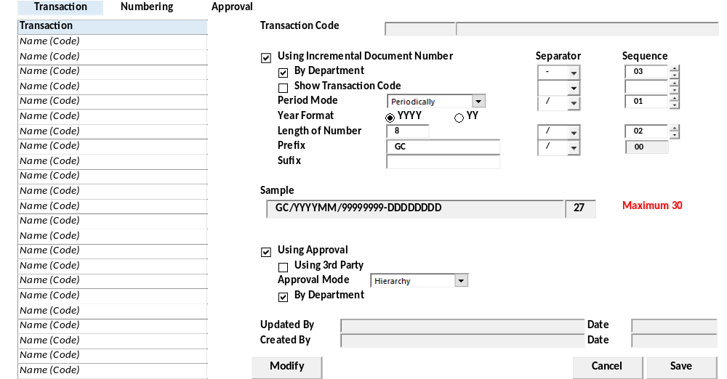

BUTTON DEFINITION
Test
- Modify – untuk melakukan update record suatu Transaction Code pada master Transaction Profile
- Save – untuk menyimpan informasi perubahan pada suatu Transaction Code
- Cancel – untuk menggagalkan perubahan pada suatu Transaction Code
- X – untuk keluar dari program Transaction Profile

OUTPUT
Test
- None.

ROLES
Test
- Program ini dijalankan oleh operator yang mempunyai hak kewenangan menjalankan Global System.

INITIAL PROCESS
Test
- Load Form:

- Baca database master Transaction Profile dan ditampilkan pada list of Transaction Profile.
[CR03]
Select A.*, CMODULE_NAME = Isnull((Select Top 1 RTRIM(CMODULE_NAME)
From SAM_PROGRAM (Nolock) Where CMODULE_ID = A.CMODULE_ID), ***Not found***)
From GSM_TRANSACTION_CODE A (Nolock)
WHERE A.CCOMPANY_ID = [Login Company Id]
ORDER BY A.CTRANSACTION_CODE, A.CMODULE_ID ASC

EXEC RSP_GS_GET_TRANS_CODE_LIST [Login Company Id], [Login User Id]
[CR03/]

- Baca database master Transaction Profile yang sesuai selected record pada list of Transaction Profile dan ditampilkan pada form Transaction Profile
[CR03]
Select A.* From GSM_TRANSACTION_CODE A (Nolock)
Where A.CCOMPANY_ID = [Login Company Id]
AND A.CTRANSACTION_CODE = Selected "Code" in list of Transaction Profile

EXEC RSP_GS_GET_TRANS_CODE_INFO [Login Company Id] , [Selected Trans Code]
[CR03/]
- Jalankan "DISPLAY PROCESS"
- Set Focus pada button "Modify"

DISPLAY PROCESS
Test
- List of Transaction Profile (lihat Initial Process)
  - Definisi Fields:
    - "Code"
      - Textbox
      - Field = [CR03] CTRANS_CODE CTRANSACTION_CODE
    - "Transaction Name"
      - Textbox
      - Field = [CR03] CTRANS_NAME CTRANSACTION_NAME
    - "Module"
      - Combobox
      - Field = CMODULE_NAME
  - Grouping by "Module"
  - Read Only.
- Form Transaction Profile (lihat Initial Process)
  - All fields disabled
  - Definisi Fields:
    - "Transaction Code"
      - Textbox
      - Field = [CR03] CTRANS_CODE, CTRANSACTION_CODE, CTRANSACTION_NAME
    - "Using Incremental Document Number"
      - Checkbox
      - Field = LINCREMENT_FLAG.Convert(If 1 then Checked else Uncheked)
    - "By Department* (Numbering)"
      - Combobox
      - Field = LDEPT_MODE.Convert(If 1 then
"Each Department" else "All Department")
    - “Delimiter”
      - Field: [CDEPT_DELIMITER]
      - Combo Box
      - Value:
        - Query:
SELECT * FROM RFT_GET_GSB_CODE_INFO ('SIAPP', 'Login Company Id', '_GS_REFNO_DELIMITER', '', 'Login Language Id')

        - Value: [CODE]
        - Display: [DESCRIPTION]
    - "Show Transaction Code"
    - Checkbox
    - Field = LTRANSACTION_MODE.Convert(If 1 then
"Checked" else "Unchecked")
    - “Delimiter”
      - Field: [CTRANSACTION_DELIMITER]
      - Combo Box
      - Value:
        - Query:
SELECT * FROM RFT_GET_GSB_CODE_INFO ('SIAPP', 'Login Company Id', '_GS_REFNO_DELIMITER', '', 'Login Language Id')

        - Value: [CODE]
        - Display: [DESCRIPTION]
    - "Period Mode" =
      - Combobox
      - Field = CPERIOD_MODE
      - Value =
        - N = None Default
        - P = Periodically
        - Y = Yearly
    - “Delimiter”
      - Field: [CPERIOD_DELIMITER]
      - Combo Box
      - Value:
        - Query:
SELECT * FROM RFT_GET_GSB_CODE_INFO ('SIAPP', 'Login Company Id', '_GS_REFNO_DELIMITER', '', 'Login Language Id')

        - Value: [CODE]
        - Display: [DESCRIPTION]
    - "Year Format" =
      - Field: [CYEAR_FORMAT]
      - Radio Button
      - Enable IF "Period Mode" <> 'N' None
      - Value =
        - [1] YY
        - [2] YYYY (default)
    - "Length of Number*"
      - Field: [INUMBER_LENGTH]
      - Spinner
      - Miminum Value: 2
      - Maximum Value: 10
    - “Delimiter”
      - Field: [CNUMBER_DELIMITER]
      - Combo Box
      - Value:
        - Query:
SELECT * FROM RFT_GET_GSB_CODE_INFO ('SIAPP', 'Login Company Id', '_GS_REFNO_DELIMITER', '', 'Login Language Id')

        - Value: [CODE]
        - Display: [DESCRIPTION]
    - "Prefix" = Textbox = CPREFIX
    - “Delimiter”
      - Field: [CPREFIX_DELIMITER]
      - Combo Box
      - Value:
        - Query:
SELECT * FROM RFT_GET_GSB_CODE_INFO ('SIAPP', 'Login Company Id', '_GS_REFNO_DELIMITER', '', 'Login Language Id')

        - Value: [CODE]
        - Display: [DESCRIPTION]
    - "Suffix" = Textbox = CSUFFIX
    - "Sequence (By Department)"
      - Spinner
      - Value = (When CSEQUENCE01=01 then 1
When CSEQUENCE02=01 then 2
When CSEQUENCE03=01 then 3
When CSEQUENCE04=01 then 4
Else 0)
    - "Sequence (By Transaction Code)"
      - Spinner
      - Value = (When CSEQUENCE01=02 then 1
When CSEQUENCE02=02 then 2
When CSEQUENCE03=02 then 3
When CSEQUENCE04=02 then 4
Else 0)
    - "Sequence (Period Mode)"
      - Spinner
      - Value = (When CSEQUENCE01=03 then 1
When CSEQUENCE02=03 then 2
When CSEQUENCE03=03 then 3
When CSEQUENCE04=03 then 4
Else 0)
    - "Sequence (Length of Number)"
      - Spinner
      - Value = (When CSEQUENCE01=04 then 1
When CSEQUENCE02=04 then 2
When CSEQUENCE03=04 then 3
When CSEQUENCE04=04 then 4
Else 0)
    - "Sequence (Prefix)"
      - Spinner
      - Value =(When CSEQUENCE01=05 then 1
When CSEQUENCE02=05 then 2
When CSEQUENCE03=05 then 3
When CSEQUENCE04=05 then 4
Else 0)

    - "Example Format of Document"
      - Label = lihat Sub Format Document
    - "Using Approval"
      - Checkbox
      - Field = LAPPROVAL_FLAG.Convert(If 1 then
Checked else Unchecked)
    - "Use Third Party"
      - Checkbox
      - Field = LUSE_THIRD_PARTY.Convert(If 1 then Checked
else Unchecked)
    - "Approval Mode*"
      - Combobox
      - Field = CAPPROVAL_MODE.Convert(
When 1 then "Hierarchy"
When 2 then "Flat And"
When 3 then "Flat Or"
Else "")
    - "By Department* (Approval)"
      - Combobox
      - Field = LAPPROVAL_DEPT.Convert(If 1
then "Each Department" else "All Department")
    - "Updated By"
      - Textbox
      - Field = CUPDATE_BY
    - "Updated Date
      - Textbox
      - Field = DUPDATE_DATE
    - "Created By"
      - Textbox
      - Field = CCREATE_BY
    - "Created Date
      - Textbox
      - Field = DCREATE_DATE

- Definisi Button:
  - "Modify" – enabled
  - "Save" - disabled
  - "Cancel" - disabled
- Sub Format Document:
Set @REFNO =
Concat(
Trim(CPREFIX)

+ Iif("", "",
"-" CPREFIX_DELIMITER]
) +

When CSEQUENCE01=01 then "DDDDDDDD"
When CSEQUENCE01=02 then "TTTTTT"
When CSEQUENCE01=03 then Iif(CPERIOD_MODE=1, "YYYYMM", "YYYY")
When CSEQUENCE01=04 then "9".Replicate(INUMBER_LENGTH)
Else ""

+ Iif("", "",
"-"
When CSEQUENCE01=01 then [CDEPT_DELIMITER]
When CSEQUENCE01=02 then [CTRANSACTION_DELIMITER]
When CSEQUENCE01=03 then [CPERIOD_DELIMITER]
When CSEQUENCE01=04 then [CNUMBER_DELIMITER]
Else ""
) +

When CSEQUENCE02=01 then "DDDDDDDD"
When CSEQUENCE02=02 then "TTTTTT"
When CSEQUENCE02=03 then Iif(CPERIOD_MODE=1, "YYYYMM", "YYYY")
When CSEQUENCE02=04 then "9".Replicate(INUMBER_LENGTH)
Else ""

+ Iif("", "",
"-"
When CSEQUENCE01=01 then [CDEPT_DELIMITER]
When CSEQUENCE01=02 then [CTRANSACTION_DELIMITER]
When CSEQUENCE01=03 then [CPERIOD_DELIMITER]
When CSEQUENCE01=04 then [CNUMBER_DELIMITER]
Else ""
) +

When CSEQUENCE03=01 then "DDDDDDDD"
When CSEQUENCE03=02 then "TTTTTT"
When CSEQUENCE03=03 then Iif(CPERIOD_MODE=1, "YYYYMM", "YYYY")
When CSEQUENCE03=04 then "9".Replicate(INUMBER_LENGTH)
Else ""

+ Iif("", "",
"-"
When CSEQUENCE01=01 then [CDEPT_DELIMITER]
When CSEQUENCE01=02 then [CTRANSACTION_DELIMITER]
When CSEQUENCE01=03 then [CPERIOD_DELIMITER]
When CSEQUENCE01=04 then [CNUMBER_DELIMITER]
Else ""
) +

When CSEQUENCE04=01 then "DDDDDDDD"
When CSEQUENCE04=02 then "TTTTTT"
When CSEQUENCE04=03 then Iif(CPERIOD_MODE=1, "YYYYMM", "YYYY")
When CSEQUENCE04=04 then "9".Replicate(INUMBER_LENGTH)
Else ""

+ Iif("", "",
"-"
When CSEQUENCE01=01 then [CDEPT_DELIMITER]
When CSEQUENCE01=02 then [CTRANSACTION_DELIMITER]
When CSEQUENCE01=03 then [CPERIOD_DELIMITER]
When CSEQUENCE01=04 then [CNUMBER_DELIMITER]
Else ""
) +

Trim(CSUFFIX)
)
- If @REFNO.length() > 30 Then raise Error Message “Reference Number length cannot exceed 30 characters”
- Else Display @REFNO

EDIT PROCESS
Test
- Check Locking another User. If Yes then Display Message and Return False Else Set Locking End If
- Get Old Value of:
  - "Enable Incremental Document (Numbering)",
  - "Enable Approval Process",
  - "Use Third Party"
- Set Old Value:
  - Var_Old_Enable_Incremental_Document_Numbering,
  - Var_Old_By_Department_Incremental
  - Var_Old_By_Transaction_Code
  - Var_Old_Period_Mode
  - Var_Old_Year_Format
  - Var_Old_Enable_Approval_Process,
  - Var_Old_By_Department_Approval
  - Var_Old_Use_Third_Party
- Enabled all fields in form Transaction Profile
- Disabled "Transaction Code", "Transaction Name", "Update By", "Update Date"
- Disabled all button
- Enabled button "Save", "Cancel"
- Input enable fields
    - "Enable Incremental Document (Numbering)"
  - If Checked:
    - By Department (Numbering) iif(Checked, enabled, disabled)
      - Delimiter(Department) iif(“By Department”.Checked, enabled, disabled)
    - Show Transaction Code iif(Checked, enabled, disabled)
      - Delimiter(Show Transaction Code) iif(“Show Transaction Code”.Checked, enabled, disabled)
    - Period Mode iif(Checked, enabled, disabled)
    - Year Format iif(Checked, enabled, disabled)
    - Length of Number iif(Checked, enabled, disabled)
    - Prefix iif(Checked, enabled, disabled)
    - Suffix iif(Checked, enabled, disabled)
  - If Unchecked:
    - Set Value
      - By Department (Numbering) = “”
      - Show Transaction Code = “”
      - Period Mode = “”
      - Prefix.Value = “”
      - Suffix.Value = “”
      - Length of Number = 0
    - Set Disabled
      - By Department (Numbering)
      - Show Transaction Code
      - Period Mode
      - Length of Number
      - Prefix.Value
      - Suffix.Value
      - Delimiter By Department (Numbering)
      - Delimiter Show Transaction Code
      - Delimiter Period Mode
      - Delimiter Year Format
      - Delimiter Length of Number
      - Delimiter Prefix.Value
    - "By Department* (Numbering)"
  - Options: "Each Department", "All Department"
  - LostFocus(
    - If "Enable Incremental" = Checked AndAlso "Each Department" then
      - "Delimiter (By Department)" enabled
      - "Sequence (By Department)" enabled
    - Else:
      - "Delimiter (By Department)".value = “”
      - "Delimiter (By Department)" disabled
      - "Sequence (By Department)".Value = 0
      - "Sequence (By Department)" disabled
    - End if
    - Run Sequence By Department.InteractiveChange())
    - "Show Transaction Code*"
  - Options: "Yes", "No"
  - LostFocus(
    - If "Yes" then
      - "Delimiter (Show Transaction Code)" enabled
      - "Sequence (Show Transaction Code)" enabled
    - Else:
      - "Delimiter (Show Transaction Code)".value = “”
      - "Delimiter (Show Transaction Code)" disabled
      - "Sequence (Show Transaction Code)".Value = 0
      - "Sequence (Show Transaction Code)" disabled)
    - End if
    - Run Sequence By Transaction Code.InteractiveChange())
    - "Period Mode"
  - Options:
    - N = None
    - P = Periodically
    - Y = Yearly
  - LostFocus(
    - If "Enable Incremental" = Checked then
      - "Delimiter (Period Mode)" enabled
      - "Sequence (Period Mode)" enabled
    - Else
      - "Delimiter (Period Mode)".value = “”
      - "Delimiter (Period Mode)" Disabled
      - "Sequence (Period Mode)" disabled
    - Run Sequence Period Mode.InteractiveChange())
    - "Year Format"
  - Options: "YYYY", "YY"
  - LostFocus(Enable IF "Period Mode" <> ‘N’ None

    - "Length of Number*"
  - Only Numeric
  - LostFocus(
    - If "Enable Incremental" = Checked then
      - "Delimiter (Length of Number)" enabled
      - "Sequence (Length of Number)" enabled
    - Else
      - "Delimiter (Length of Number)".value = “”
      - "Delimiter (Length of Number)" disabled
      - "Sequence (Length of Number)" disabled
    - Run Sequence Length of Number.InteractiveChange())
    - "Prefix"
  - Maximum 29 Character
  - Set Normal Character Case
  - If "Enable Incremental" = Checked then
    - "Delimiter (Prefix)" enabled
  - Else
    - "Delimiter (Prefix)".value = “”
    - "Delimiter (Prefix)" disabled
    - "Suffix"
  - Maximum 29 Character
  - Set Normal Character Case
    - "Delimiter (By Department)"
  - OnChange: InteractiveChange(run Sub Format Document)
    - "Delimiter (By Transaction Code)"
  - OnChange: InteractiveChange(run Sub Format Document)
    - "Delimiter (Period Mode)"
  - OnChange: InteractiveChange(run Sub Format Document)
    - "Delimiter (Length of Number)"
  - OnChange: InteractiveChange(run Sub Format Document)
    - "Delimiter (Prefix)"
  - OnChange: InteractiveChange(run Sub Format Document)
    - "Sequence (By Department)"
  - Range 0 – 4
  - InteractiveChange(run Sub Format Document)
    - "Sequence (Show Transaction Code)"
  - Range 0 - 4
  - InteractiveChange(run Sub Format Document)
    - "Sequence (Period Mode)"
  - Range 0 - 4
  - InteractiveChange(run Sub Format Document)
    - "Sequence (Length of Number)"
  - Range 0 - 4
  - InteractiveChange(run Sub Format Document)
    - "Using Approval"
  - InteractiveChange(
    - If Checked then
      - Set enable Tab “Approval” Else disabled
      - Set "Use Third Party" enabled
      - If "Use Third Party".checked = True
        - "Approval Mode", "By Department (Approval)" disabled
      - Else
        - "Approval Mode", "By Department (Approval)" enabled
    - else
      - Set "Use Third Party" = UnChecked
      - "Use Third Party", "Approval Mode", "By Department (Approval)" disabled)
    - "Use Third Party"
  - InteractiveChange(If Checked then "Approval Mode", "By Department (Approval)" disabled else enabled)
    - "Approval Mode*"
  - Options: 1 = "Hierarchy", 2 = "Flat And", 3 = "Flat Or"
    - "By Department* "
  - Checkbox
  - [0] Unchecked, [1] Checked
- Validation Process:
  - If "Using Approval" = Checked & "Use Third Party" = Unchecked & "Approval Mode*" = Empty then
    - Display Message "You must fill Approval Mode" with OK button, cancel Save Process
  - If Var_Old_Enable_Incremental_Document_Numbering different with New Value of "Enable Incremental Document (Numbering)"
    - If exists(select top 1 1 from GSM_TRANSACTION_NUMBER (nolock) where CCOMPANY_ID and CTRANSACTION_CODE) begin
      - Display Message "There is some detail in Detail Document Numbering table. Your data changing will delete all Detail Document Numbering table." with Cancel or Continue
      - If Cancel then Return False End If
    - End If
  - ElseIf Var_Old_By_Department_Incremental different with New Value of "By Department Incremental Document (Numbering)"
    - If exists(select top 1 1 from GSM_TRANSACTION_NUMBER (nolock) where CCOMPANY_ID and CTRANSACTION_CODE) begin
      - Display Message "There is some detail in Detail Document Numbering table. Your data changing will delete all Detail Document Numbering table." with Cancel or Continue
      - If Cancel then Return False End If
    - End If
  - ElseIf Var_Old_By_Transaction_Code different with New Value of "By Transaction Code Incremental Document (Numbering)"
    - If exists(select top 1 1 from GSM_TRANSACTION_NUMBER (nolock) where CCOMPANY_ID and CTRANSACTION_CODE) begin
      - Display Message "There is some detail in Detail Document Numbering table. Your data changing will delete all Detail Document Numbering table." with Cancel or Continue
      - If Cancel then Return False End If
    - End If
  - ElseIf Var_Old_Period_Mode different with New Value of "Period Mode Incremental Document (Numbering)"
    - If exists(select top 1 1 from GSM_TRANSACTION_NUMBER (nolock) where CCOMPANY_ID and CTRANSACTION_CODE) begin
      - Display Message "There is some detail in Detail Document Numbering table. Your data changing will delete all Detail Document Numbering table." with Cancel or Continue
      - If Cancel then Return False End If
    - End If
  - If Var_Old_Enable_Approval_Process different with New Value of "Enable Approval Process"
    - If exists(select top 1 1 from GSM_TRANSACTION_APPROVAL (nolock) where CCOMPANY_ID and CTRANSACTION_CODE) begin
      - Display Message "There is some detail in User Approval table. Your data changing will delete all User Approval table." with Cancel or Continue
      - If Cancel then Return False End If
    - End If
  - ElseIf Var_Old_By_Department_Approval different with New Value of "By Department Approval Process"
    - If exists(select top 1 1 from GSM_TRANSACTION_APPROVAL (nolock) where CCOMPANY_ID and CTRANSACTION_CODE) begin
      - Display Message "There is some detail in User Approval table. Your data changing will delete all User Approval table." with Cancel or Continue
      - If Cancel then Return False End If
(Notes: akan sekaligus menghapus table User Replacement)
    - End If
  - ElseIf Var_Old_Use_Third_Party = UnChecked and different with New Value of "Use Third Party" = Checked
    - If exists(select top 1 1 from GSM_TRANSACTION_APPROVAL (nolock) where CCOMPANY_ID and CTRANSACTION_CODE) begin
      - Display Message "There is some detail in User Approval table. Your data changing will delete all User Approval table." with Cancel or Continue
      - If Cancel then Return False End If
    - End If
- Save Process:
  - "Sequence (By Department)"
    - Jika kosong (0) dan "Enable Incremental" = Checked dan "Each Department" tampilkan pesan "You should fill Sequence By Department", Ok
  - "Sequence (By Transaction Code)"
    - Jika kosong (0) dan "By Transaction Code" = "Yes" tampilkan pesan "You should fill Sequence By Transaction Code", Ok
  - "Sequence (Period Mode)"
    - Jika kosong (0) dan "Enable Incremental" = Checked tampilkan pesan "You should fill Sequence Period Mode", Ok
  - "Sequence (Length of Number)"
    - Jika kosong (0) dan "Enable Incremental" = Checked tampilkan pesan "You should fill Sequence Length of Number", Ok
  - Jika "Sequence" harus diisi, maka:
    - Masing-masing "Sequence" tidak boleh ada yang sama nilainya satu sama lain, tampilkan pesan "Sequence value can not same each other", Ok
    - Masing-masing "Sequence" tidak boleh overlap (misal Sequence yang harus diisi hanya 2 spinner, tetapi nilai masing-masing dari 1 langsung ke 3 atau 4) dan juga harus urut dari 1-4, tampilkan pesan "Sequence can not overlap or else must Sequential from 1 to 4", Ok
  - Validasi Length of Document, tampilkan pesan "Maximum Length of Document is 30 (without -)", Ok
  - If error not found:
    - Update Database selected record di master Transaction Profile

Update GSM_TRANSACTION_CODE
LINCREMENT_FLAG = "Enable Incremental Document (Numbering)".Convert(If
Checked then 1 else 0)
LDEPT_MODE = "By Department (Numbering)".Convert(If Each Department
then 1 else 0)
CDEPT_DELIMITER = “Delimiter (Department)”
LTRANSACTION_MODE = "By Transaction Code".Convert(If Yes then 1 else 0)
CTRANSACTION_DELIMITER = “Delimiter (Transaction Code)”
CPERIOD_MODE = "Period Mode".[N = None / P = Periodically / Y = Yearly]
CYEAR_FORMAT = "Year Format". [2] YYYY / [1] YY
CPERIOD_DELIMITER = “Delimiter (Period Mode)”
INUMBER_LENGTH = "Length of Number"
CNUMBER_DELIMITER = “Delimiter (Number)”
CPREFIX = "Prefix"
CPREFIX_DELIMITER = “Delimiter (Prefix)”
CSUFFIX = "Suffix"
CSEQUENCE01 = When "Sequence By Department"=1 then 01
When "Sequence By Transaction Code"=1 then 02
When "Sequence Period Mode"=1 then 03
When "Sequence Length of Number"=1 then 04
CSEQUENCE02 = When "Sequence By Department"=2 then 01
When "Sequence By Transaction Code"=2 then 02
When "Sequence Period Mode"=2 then 03
When "Sequence Length of Number"=2 then 04
CSEQUENCE03 = When "Sequence By Department"=3 then 01
When "Sequence By Transaction Code"=3 then 02
When "Sequence Period Mode"=3 then 03
When "Sequence Length of Number"=3 then 04
CSEQUENCE04 = When "Sequence By Department"=4 then 01
When "Sequence By Transaction Code"=4 then 02
When "Sequence Period Mode"=4 then 03
When "Sequence Length of Number"=4 then 04

LAPPROVAL_FLAG = "Enable Approval Process".Convert(If Checked
then 1 else 0)
LUSE_THIRD_PARTY = "Use Third Party".Convert(If Checked then 1 else 0)
CAPPROVAL_MODE = "Approval Mode".Convert(When "Hierarcy" then 1
When "Flat And" then 2
When "Flat Or" then 3)
LAPPROVAL_DEPT = "By Department (Approval)".Convert(If Each Department then 1 else 0)
CUPDATE_BY = login User Id
DUPDATE_DATE = GETDATE()
Where
CCOMPANY_ID = Login Company Id
AND CTRANSACTION_CODE = Transaction Code

- Jalankan "DISPLAY PROCESS"

CANCEL PROCESS
Test
- Back to old record

TAB – NUMBERING

USER INTERFACE
[CR02]
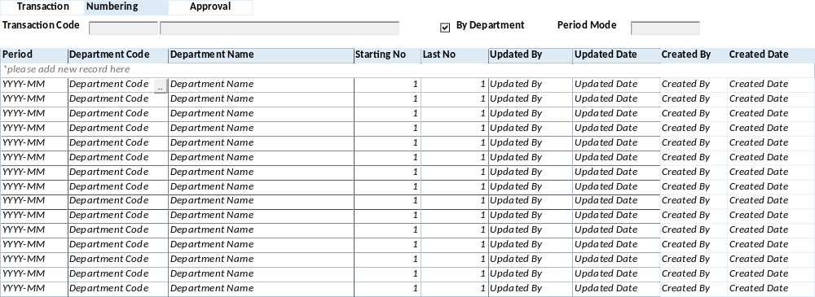

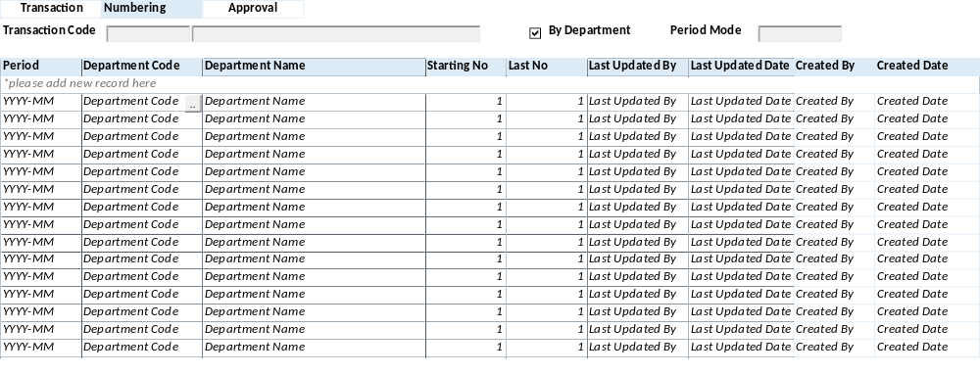

BUTTON DEFINITION
Test
- Add – Untuk menambah data User Approval
- Edit – Untuk mengubah isi data User Approval
- Delete – Untuk menghapus informasi data User Approval
- Save – Untuk menyimpan isi informasi data User Approval
- Cancel – Untuk membatalkan perubahan isi data User Approval

OUTPUT
Test

ROLES
Test
- Program ini dijalankan oleh operator yang mempunyai hak kewenangan menjalankan Global System.

INITIAL PROCESS
Test
[CR04]
- This Tab enable IF "Using Incremental Document Number" = True
- Display Data Transaction Code

SELECT CTRANSACTION_CODE
, CTRANSACTION_NAME
, LDEPT_MODE
, CPERIOD_MODE
, (CASE WHEN CPERIOD_MODE = 'N' THEN 'None'
WHEN CPERIOD_MODE = 'P' THEN 'Periodically'
WHEN CPERIOD_MODE = 'Y' THEN 'Yearly' END) AS CPERIOD_MODE_DESCR
FROM GSM_TRANSACTION_CODE (NOLOCK)
WHERE CCOMPANY_ID = [Login Company Id]
AND CTRANSACTION_CODE = [Selected Transaction Code]

- Display Header data [TRANSACTION_CODE_HEADER]:

  - "Transaction Code"
    - Textbox
    - Display = CTRANSACTION_CODE, CTRANSACTION_NAME

  - "By Department"
    - Checkbox
    - Display = LDEPT_MODE
    - Value [1] Checked, [0] Unchecked

  - "Period Mode"
    - Textbox
    - Display = CPERIOD_MODE_DESCR

DISPLAY PROCESS
Test
- Load Transaction Code Numbering List [NUMBERING_LIST]

EXEC RSP_GS_GET_TRANS_CODE_NUMBER_LIST @CCOMPANY_ID, [Selected Transaction Code], @CUSER_LOGIN_ID

- Display data [NUMBERING_LIST]:
  - "Period"
    - Textbox
    - Display = CYEAR - CPERIOD_NO
    - VARCHAR(20)
    - Automatic generate This Year Period
      - IF Period Mode = [P] Periodically
THEN YYYY – MM
      - IF Period Mode = [Y] Yearly THEN YYYY

  - "Department Code"
    - Lookup
    - Disabled IF "By Department" = Unchecked
    - Display = CDEPT_CODE
    - Value = GSL00700 – DEPARTMENT LOOKUP
with Parameter:
'Login Company Id'
, 'CUSER_ID'

  - "Department Name"
    - Textbox
    - Display = CDEPT_NAME
    - VARCHAR(100)
    - Automatic Filled from Department Lookup

  - "Starting No."
    - Numbering Spinner
    - Display = ISTART_NUMBER
    - Min Value = 1 [default]
    - Max Value = 1000
    - Stepping Value = 1

  - "Last No"
    - Textbox
    - Display = ILAST_NUMBER
    - Disabled

  - [CR02] "Last Update By" "Updated By"
    - Textbox
    - Display = CUPDATE_BY
    - Value = User Login Id
    - Disabled

  - [CR02] "Last Update Date" "Updated Date"
    - Textbox
    - Display = DUPDATE_DATE
    - Value = Today Date
    - Disabled

- Proses
        - "Add New" → Go to ADD NEW PROCESS
        - "Edit"→ Go to EDIT PROCESS
        - "Delete"→ Go to DELETE PROCESS

ADD NEW PROCESS
Test
- Set VAR_SAVE_MODE = NEW
- Enabled fields: All Field
- Disabled fields: "Period No", "Last Number", "Last Update By", "Last Update Date"
- Set focus to column: "Department Code"

- Proses
        - “Save” → Go to SAVE & VALIDATION PROCESS
        - “Cancel”→ Go to DISPLAY PROCESS

EDIT PROCESS
Test
- Validation:
- Jalankan RSP_ACTIVITY_VALIDITY {Login Company ID}, 'GSM04001'
          - If no Error maka jalankan :
            - Baca result,
            - Munculkan Pop Up dengan
              - Label Reason = {Text Box Double byte max 100}
              - Button = OK / Cancel
              - Tampung Nilai di @DETAIL_ACTION
            - If Result count = 1 and value = All, maka jalankan update
            - If Result Value <> 1 dan value <> = All maka buka GFF00900
              - @PROPERTY_NO ={Login Property Id}
              - @ACTION_CODE = 'GSM05001'
              - @DATE = @ActiveDate
              - @REQUEST_BY = {Login User Id}
              - @DETAIL_ACTION = CCOMPANY_ID + ‘|’ + hasil detail action
              - @USER_LIST = Result SP

          - Setelah melalui process applikasi tersebut, Bila Sukses jalankan :
[RSP_CREATE_ACTIVITY_APPROVAL_LOG]
@P_CCOMPANY_ID = {Login Company Id}
@P_CAPPROVAL_CODE = 'GSM05001'
@P_CREFERENCE_NO = CCOMPANY_ID
@P_CREFERENCE_INFO = CCOMPANY_ID + ‘|’ + hasil detail action
@P_DAPPROVAL_DATE = @ActiveDate
@P_CAPPROVAL_USER_ID = {Return User Id}
@P_CACTIVITY_USER_ID = {Login user Id}
@P_CREASON_CODE = ''
@P_CAPPROVAL_NOTE = @ACTION_DETAIL

- Set VAR_SAVE_MODE = EDIT
- Enabled fields: "Start No"
- Set focus to column: "Start No"

- Proses
        - “Save” → Go to SAVE & VALIDATION PROCESS
        - “Cancel”→ Go to DISPLAY PROCESS

DELETE PROCESS
Test
- Set VAR_SAVE_MODE = DELETE

- DELETE PROCESS
EXEC RSP_GS_MAINTAIN_TRANS_CODE_NUMBERING
"Login Company Id"
, "Period" Year IF [CYEAR_FORMAT] = 1 THEN YY, ELSE IF [CYEAR_FORMAT] = 2 THEN YYYY
, "Period" No. IF [CPERIOD_MODE] = [Y] Yearly THEN ‘’ ELSE Generate running from 00, 01, 02, dst. [Last No + 1]
, "Department Code"
, "Start Number"
, "DELETE"
, Login User Id

SAVE & VALIDATION PROCESS
Test
- Save Numbering

EXEC RSP_GS_MAINTAIN_TRANS_CODE_NUMBERING
"Login Company Id"
, [Selected Property Id]
, "Period" Year IF [CYEAR_FORMAT] = 1 THEN YY, ELSE IF [CYEAR_FORMAT] = 2 THEN YYYY
, "Period" No. IF [CPERIOD_MODE] = [Y] Yearly THEN ‘’ ELSE Generate running from 00, 01, 02, dst. [Last No + 1]
, "Department Code"
, "Start Number"
, CACTION [ADD]
, Login User Id

- Go to DISPLAY PROCESS

CANCEL PROCESS
Test
- Tutup program dan kembali ke Numbering List

TAB – APPROVAL

USER INTERFACE
[CR02]
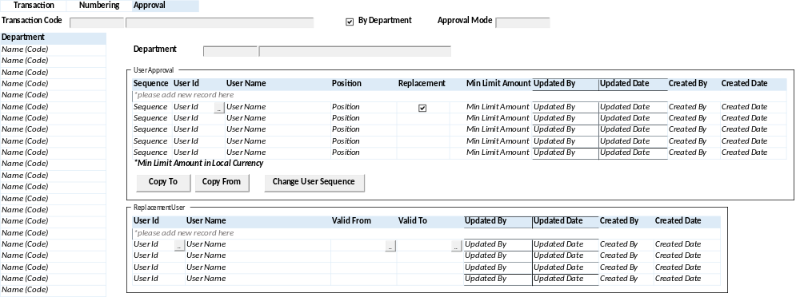
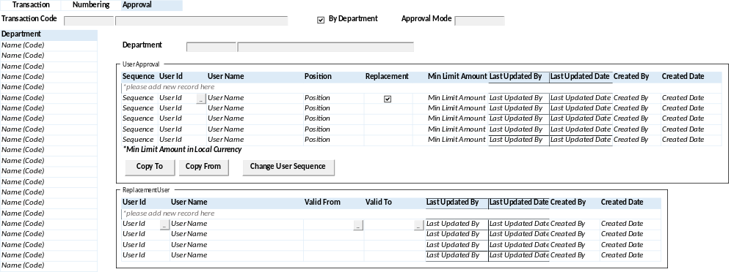

INITIAL PROCESS
Test
[CR04]
This Tab enable IF "Using Approval" = True

- Display Data Transaction Code
[CR03]
^{[CR01]}
^{SELECT CTRANSACTION_CODE}
^{, CTRANSACTION_NAME}
^{, LDEPT_MODE}
^{, CPERIOD_MODE}
, (CASE WHEN CPERIOD_MODE = 'N' THEN 'None'
WHEN CPERIOD_MODE = 'P' THEN 'Periodically'
WHEN CPERIOD_MODE = 'Y' THEN 'Yearly' END) AS CPERIOD_MODE_DESCR
FROM GSM_TRANSACTION_CODE (NOLOCK)
WHERE CCOMPANY_ID = [Login Company Id]
AND CPROPERTY_ID = [Selected Property Id]
AND CTRANSACTION_CODE = [Selected Transaction Code]

^{SELECT CTRANSACTION_CODE}
^{, CTRANSACTION_NAME}
^{, LDEPT_MODE}
^{, CPERIOD_MODE}
^{, CAPPROVAL_MODE}
, ISNULL((CASE WHEN CAPPROVAL_MODE = '1' THEN 'Hierarchy'
WHEN CAPPROVAL_MODE = '2' THEN 'Flat And'
WHEN CAPPROVAL_MODE = '3' THEN 'Flat Or' END),'') AS CAPPROVAL_MODE_DESCR
FROM GSM_TRANSACTION_CODE (NOLOCK)
WHERE CCOMPANY_ID = [Login Company Id]
AND CPROPERTY_ID = [Selected Property Id]
AND CTRANSACTION_CODE = [Selected Transaction Code]
^{[\CR01]}
EXEC RSP_GS_GET_TRANS_CODE_INFO [Login Company Id] , [Selected Trans Code]
[CR03/]
- Display Header data [TRANSACTION_CODE_HEADER]:

  - "Transaction Code"
    - Textbox
    - Display = [CR03] CTRANS_CODE CTRANSACTION_CODE, CTRANSACTION_NAME

  - "By Department"
    - Checkbox
    - Display = LDEPT_MODE
    - Value [1] Checked, [0] Unchecked

  - [CR01]"Period Mode" "Approval Mode"
    - Textbox
    - Display = [CR01]CPERIOD_MODE_DESCR CAPPROVAL_MODE_DESCR

DISPLAY PROCESS
Test
- Department List Enable IF "By Department" = Checked, ELSE DISABLED do not Loat Department List

- Load Department List [DEPT_LIST]
[CR03]
SELECT CDEPT_CODE, CDEPT_NAME FROM GSM_DEPARTMENT (NOLOCK)
WHERE CCOMPANY_ID = 'Login Company Id'
AND LACTIVE = 1

EXEC RSP_GS_GET_DEPT_LOOKUP_LIST 'Login Company Id', [Login User Id]
[CR03/]

Display Data:
  - "Department Name"
    - Textbox
    - Display = CDEPT_NAME (CDEPT_CODE)
    - VARCHAR(100)

- Load Transaction Code Approver List [APPROVER_LIST]

EXEC RSP_GS_GET_TRANS_CODE_APPROVER_LIST @CCOMPANY_ID, [Selected Transaction Code], @CUSER_LOGIN_ID

- Display data [APPROVER_LIST]:
  - "Sequence"
    - Textbox
    - Display =[CR04] CSEQUENCE ISEQUENCE
    - Set [CR04] [000] [0] IF Transaction.CAPPROVAL_MODE <> ‘1’ Structural
    - Set [CR04] 001 [1] IF there’s no data for this Transaction, Else set Last Sequence + 1

  - "User Id"
    - Lookup
    - Display = CUSER_ID
    - Value = GSL01100 – USER APPROVAL LOOKUP

  - "User Name"
    - Textbox
    - Display = CUSER_NAME
    - VARCHAR(100)
    - Disabled

  - "Position"
    - Textbox
    - Display = CPOSITION
    - VARCHAR(100)
    - Disabled

  - "Replacement"
    - Checkbox
    - Display = LREPLACEMENT
    - Value = [0] Unchecked / [1] Checked
    - Default Value = [0]

  - "Min Limit Amount"
    - Numeric Spinner
    - Display = NLIMIT_AMOUNT
    - Min Value = 0
    - Max Value = 999,999,999
    - Stepping Value = 1

  - [CR02] "Last Updated By"
    - Textbox
    - Display = CUPDATE_BY
    - Value = User Login Id
    - Disabled

  - [CR02] "Last Updated Date"
    - Textbox
    - Display = DUPDATE_DATE
    - Value = Today Date
    - Disabled

  - "Created By"
    - Textbox
    - Display = CCREATE_BY
    - Value = User Login Id
    - Disabled

  - "Created Date"
    - Textbox
    - Display = DCREATE_DATE
    - Value = Today Date
    - Disabled

- Load Transaction Code Replacement List [REPLACEMENT_LIST]

EXEC RSP_GS_GET_TRANS_CODE_REPLACEMENT_LIST @CCOMPANY_ID, [Selected Transaction Code], @CDEPT_CODE, @CSELECTED_USER_ID @CUSER_LOGIN_ID

- Display data [REPLACEMENT_LIST]:
  - "User Id"
    - Lookup
    - Display = CUSER_ID
    - Value = GSL01100 – USER APPROVAL LOOKUP
  - "User Name"
    - Textbox
    - Display = CUSER_NAME
    - VARCHAR(100)
    - Disabled

  - "Valid From"
    - Datetime Picker
    - Display = CVALID_FROM
    - Default value = Today Date [with format YYYYMMDD]

  - "Valid To"
    - Datetime Picker
    - Display = CVALID_TO
    - Default value = Today Date [with format YYYYMMDD]

  - [CR02] "Last Updated By"
    - Textbox
    - Display = CUPDATE_BY
    - Value = User Login Id
    - Disabled

  - [CR02] "Last Updated Date"
    - Textbox
    - Display = DUPDATE_DATE
    - Value = Today Date
    - Disabled

  - "Created By"
    - Textbox
    - Display = CCREATE_BY
    - Value = User Login Id
    - Disabled

  - "Created Date"
    - Textbox
    - Display = DCREATE_DATE
    - Value = Today Date
    - Disabled

- Proses
        - "Add New" → Go to ADD NEW PROCESS
        - "Edit"→ Go to EDIT PROCESS
        - "Delete"→ Go to DELETE PROCESS

ADD NEW PROCESS
Test
- Set VAR_SAVE_MODE = NEW
- Enabled fields: All Field
- Disabled fields: "Sequence", "User Name", "Position", "Created By", "Created Date", "Last Update By", "Last Update Date"
- Set focus to column: "User Id"

- Proses
        - “Save” → Go to SAVE & VALIDATION PROCESS
        - “Cancel”→ Go to DISPLAY PROCESS

EDIT PROCESS
CR01 | Test
- Set VAR_SAVE_MODE = EDIT
- Enabled fields: "Replacement", "Min Limit Amount"
- Set focus to column: "Replacement"

- Proses
        - “Save” → Go to SAVE & VALIDATION PROCESS
        - “Cancel”→ Go to DISPLAY PROCESS

DELETE PROCESS
Test
- Set VAR_SAVE_MODE = DELETE
- Validasi saat DELETE, jika mengubah flag Replacement = true,
IF EXISTS(SELECT TOP 1 1 FROM GSM_TRANS_APV_REPLACEMENT (NOLOCK)
WHERE CCOMPANY_ID = @CCOMPANY_ID
AND CPROPERTY_ID = @CPROPERTY_ID
AND CTRANSACTION_CODE = @CTRANSACTION_CODE
AND CDEPT_CODE = @CDEPT_CODE
AND CUSER_ID = @CUSER_ID
)
Tampilkan message "Remove selected user will remove all replacement for this user, are you sure?" YES/NO, IF Yes, jalankan Delete Process, Else Back To Display Process

- DELETE PROCESS
EXEC RSP_GS_MAINTAIN_TRANS_CODE_APPROVER
"Login Company Id"
, [Selected Property Id]
, Selected Transaction Code
, Selected Dept Code
, "User Id"
, "Sequence"
, "Replacement"
, "Min Limit Amount"
, "DELETE"
, Login User Id

- DELETE PROCESS
EXEC RSP_GS_MAINTAIN_TRANS_CODE_APPR_REPLACE
"Login Company Id"
, [Property Id]
, Selected Transaction Code
, Selected Dept Code
, Selected User Id
, "User Id" Replacement
, "Valid From"
, "Valid To"
, "DELETE"
, Login User Id

SAVE & VALIDATION PROCESS
Test
- Validasi saat EDIT, jika mengubah flag Replacement from True to False,
IF EXISTS(SELECT TOP 1 1 FROM GSM_TRANS_APV_REPLACEMENT (NOLOCK)
WHERE CCOMPANY_ID = @CCOMPANY_ID
AND CPROPERTY_ID = @CPROPERTY_ID
AND CTRANSACTION_CODE = @CTRANSACTION_CODE
AND CDEPT_CODE = @CDEPT_CODE
AND CUSER_ID = @CUSER_ID
)
Tampilkan message "Change Replacement flag to false will remove all replacement for this user, are you sure?" YES/NO, IF Yes, jalankan Save Approver, Else Back To Display Process

- Save Approver

EXEC RSP_GS_MAINTAIN_TRANS_CODE_APPROVER
"Login Company Id"
, [Selected Property Id]
, Selected Transaction Code
, Selected Dept Code
, "User Id"
, "Sequence"
, "Replacement"
, "Min Limit Amount"
, CACTION [ADD]
, Login User Id

- Save User Replacement

EXEC RSP_GS_MAINTAIN_TRANS_CODE_APPR_REPLACE
"Login Company Id"
, [Property Id]
, Selected Transaction Code
, Selected Dept Code
, Selected User Id
, "User Id" Replacement
, "Valid From"
, "Valid To"
, CACTION [ADD]
, Login User Id

- Go to DISPLAY PROCESS

CANCEL PROCESS
Test
- Tutup program dan kembali ke Approver List

CHANGE SEQUENCE PROCESS
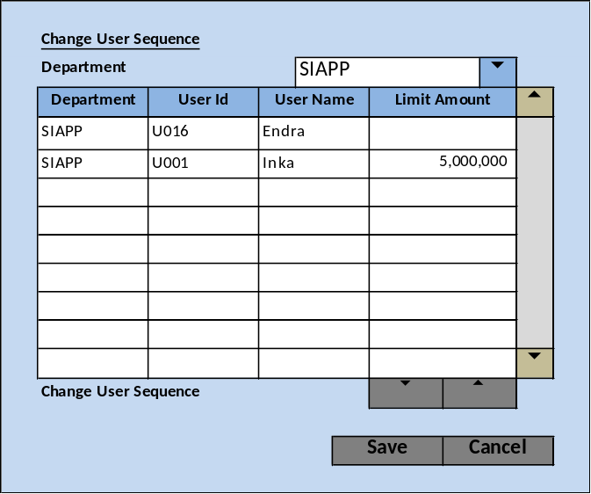

“Change Sequence” PROCESS | Test
INPUT PARAMETER
- @COMPANY_ID
- @CPROPERTY_ID
- @TRANSACTION_CODE

BUTTON DEFINITION
- Up (): Onclick execute “Up Process”
- Down (): Onclick execute “Down Process”
- Save: : Onclick execute “Save Process”
- Cancel: Onclick Close form

GET DEPARTMENT LIST
- Query “Department List”
[CR03]
SELECT A.CDEPT_CODE, B.CDEPT_NAME FROM GSM_TRANSACTION_APPROVAL A (NOLOCK)
INNER JOIN GSM_DEPARTMENT B (NOLOCK) ON A.CCOMPANY_ID = B.CCOMPANY_ID AND B.CDEPT_CODE = A.CDEPT_CODE
WHERE A.CCOMPANY_ID = B.CCOMPANY_ID AND A.CTRANSACTION_CODE = @TRANSACTION_CODE
GROUP BY A.CDEPT_CODE, B.CDEPT_NAME

EXEC RSP_GS_GET_TRANS_CODE_DEPT_LIST [Login Company Id], [Selected Trans Code], [Login User Id]
[CR03/]

GET USER SEQUENCE DATA
- @DEPARTMENT_CODE = “Department List”.”Selected”.[CDEPT_CODE]
- Query “Sequence List”
[CR03]
SELECT A.CTRANSACTION_CODE, A.CDEPT_CODE, A.CUSER_ID, A.CSEQUENCE, A. NLIMIT_AMOUNT , B.CDEPT_NAME, C.CUSER_NAME, A.CUPDATE_BY, A.DUPDATE_DATE FROM GSM_TRANSACTION_APPROVAL A (NOLOCK)
INNER JOIN GSM_DEPARTMENT B (NOLOCK) ON A.CCOMPANY_ID = B.CCOMPANY_ID AND B.CDEPT_CODE = A.CDEPT_CODE
INNER JOIN SAM_USER C (NOLOCK) ON C.CUSER_ID = A.CUSER_ID
WHERE A.CCOMPANY_ID = B.CCOMPANY_ID AND A.CTRANSACTION_CODE = @TRANSACTION_CODE AND A.CDEPT_CODE = @DEPARTMENT_CODE

EXEC RSP_GS_GET_TRANS_CODE_APPROVER_LIST [Login Company Id], [Selected CTRANS_CODE], [Login User Id], [Selected CDEPT_CODE]
[CR03/]

- Result:
  - [CR03] CPROPERTY_ID
  - [CR03] CTRANS_CODE CTRANSACTION_CODE
  - CDEPT_CODE
  - CUSER_ID
  - ISEQUENCE
  - NVALUE
  - CDEPT_NAME
  - CUSER_NAME
  - CUPDATE_BY
  - DUPDATE_DATE
- Set data into @USER_SEQ

GET MAXIMUM AND MINIMUM SEQUENCE
- @DEPARTMENT_CODE = “Department List”.”Selected”.[CDEPT_CODE]
- Query:
[CR03]
SELECT A.CPROPERTY_ID, A.CTRANSACTION_CODE, A.CDEPT_CODE, MIN(A.ISEQUENCE) AS LOWEST, MAX(A.ISEQUENCE) AS HIGHEST
FROM GSM_TRANSACTION_APPROVAL A (NOLOCK)
WHERE A.CCOMPANY_ID = @CCOMPANY_ID AND A.CTRANSACTION_CODE = @TRANSACTION_CODE AND A.CDEPT_CODE = @DEPARTMENT_CODE
GROUP BY A.CTRANSACTION_CODE, A.CDEPT_CODE

EXEC RSP_GS_GET_TRANS_CODE_APPROVER_LIST [Login Company Id], [Selected CTRANS_CODE], [Login User Id], [Selected CDEPT_CODE]
[CR03/]
- Result:
  - [CR03] CTRANS_CODE CTRANSACTION_CODE
  - CDEPT_CODE
  - LOWEST
  - HIGHEST
- Set data into @MAXMIN

DISPLAY PROCESS
Field Definition:
- Department:
  - Field: [CDEPT_CODE] – [CDEPT_NAME]
  - ComboxBox
  - Value: Run “GET DEPARTMENT LIST”
  - OnValueChange: Run “GET USER SEQUENCE DATA”
  - Refresh “Sequence List”

Sequence List
- Department
  - Field: [@USER_SEQ.CDEPT_CODE]
  - Display: [@USER_SEQ.CDEPT_NAME]
  - Textbox, disable
- User Id
  - Field: [@USER_SEQ.CUSER_ID]
  - Textbox, disable
- User Name
  - Field: [@USER_SEQ.CUSER_NAME]
  - Textbox, disable
- Limit Amount
  - Field: [@USER_SEQ.NVALUE]
  - Numeric Spinner
  - Minimum Value: 0
  - Increment by: 1000
  - Enable
  - OnLostFocus:
    - Update Limit Amount:
[CR03]
UPDATE A SET A.NVALUE = @USER_SEQ.NVALUE FROM GSM_TRANSACTION_APPROVAL A (NOLOCK) WHERE A.CCOMPANY_ID = @CCOMPANY_ID AND A.CTRANSACTION_CODE = @USER_SEQ.CTRANSACTION_CODE AND A.CDEPT_CODE = @USER_SEQ.CDEPT_CODE AND A.CUSER_ID = @USER_SEQ.CUSER_ID

EXEC RSP_GS_MAINTAIN_TRANS_CODE_APPROVER]
@CCOMPANY_ID
, @CTRANS_CODE
, @CDEPT_CODE
, @CUSER_ID
, @CSEQUENCE
, @LREPLACEMENT
, @NLIMIT_AMOUNT
, @CACTION = EDIT
, @CUSER_LOGIN_ID
[CR03/]
- On Select Row:
  - Button “Up” :
    - If Selected @USER_SEQ.ISEQUENCE < @MAXMIN.HIGHEST WHERE
@USER_SEQ.CCOMPANY_ID = @MAXMIN.CCOMPANY_ID AND
@USER_SEQ.CTRANSACTION_CODE = @MAXMIN.CTRANSACTION_CODE AND @USER_SEQ.CDEPT_CODE = @MAXMIN.CDEPT_CODE Then Set Enable
    - Else Set Disable
  - Button “Down” :
If Selected @USER_SEQ.ISEQUENCE > @MAXMIN.LOWEST WHERE @USER_SEQ.CCOMPANY_ID = @MAXMIN.CCOMPANY_ID AND
@USER_SEQ.CTRANSACTION_CODE = @MAXMIN.CTRANSACTION_CODE AND @USER_SEQ.CDEPT_CODE = @MAXMIN.CDEPT_CODE Then Set Enable
    - Else Set Disable

UP PROCESS
- Update Upper User Sequence:
  - [CR03]
UPDATE A SET A.ISEQUENCE = @USER_SEQ.ISEQUENCE FROM GSM_TRANSACTION_APPROVAL A (NOLOCK) WHERE A.CCOMPANY_ID = @USER_SEQ.CCOMPANY_ID
AND A.CTRANSACTION_CODE = @USER_SEQ.CTRANSACTION_CODE AND A.CDEPT_CODE = @USER_SEQ.CDEPT_CODE AND A.ISEQUENCE = @USER_SEQ.ISEQUENCE – 1

EXEC RSP_GS_MAINTAIN_TRANS_CODE_APPROVER]
@CCOMPANY_ID
, @CTRANS_CODE
, @CDEPT_CODE
, @CUSER_ID
, @CSEQUENCE = @USER_SEQ.ISEQUENCE
, @LREPLACEMENT
, @NLIMIT_AMOUNT
, @CACTION = EDIT
, @CUSER_LOGIN_ID
[CR03/]
- Update Current Selected User Sequence:
  - [CR03]
UPDATE A SET A.ISEQUENCE = @USER_SEQ.ISEQUENCE – 1 FROM GSM_TRANSACTION_APPROVAL A (NOLOCK) WHERE A.CCOMPANY_ID = @USER_SEQ.CCOMPANY_ID AND
A.CTRANSACTION_CODE = @USER_SEQ.CTRANSACTION_CODE AND A.CDEPT_CODE = @USER_SEQ.CDEPT_CODE AND A.CUSER_ID = @USER_SEQ.CUSER_ID

EXEC RSP_GS_MAINTAIN_TRANS_CODE_APPROVER]
@CCOMPANY_ID
, @CTRANS_CODE
, @CDEPT_CODE
, @CUSER_ID
, @CSEQUENCE = @USER_SEQ.ISEQUENCE – 1
, @LREPLACEMENT
, @NLIMIT_AMOUNT
, @CACTION = EDIT
, @CUSER_LOGIN_ID
[CR03/]

- Run “DISPLAY PROCESS”

DOWN PROCESS
- Update Lower User Sequence:
  - [CR03]
UPDATE A SET A.ISEQUENCE = @USER_SEQ.ISEQUENCE FROM GSM_TRANSACTION_APPROVAL A (NOLOCK) WHERE A.CCOMPANY_ID = @USER_SEQ.CCOMPANY_ID AND
A.CTRANSACTION_CODE = @USER_SEQ.CTRANSACTION_CODE AND A.CDEPT_CODE = @USER_SEQ.CDEPT_CODE AND A.ISEQUENCE = @USER_SEQ.ISEQUENCE + 1

EXEC RSP_GS_MAINTAIN_TRANS_CODE_APPROVER]
@CCOMPANY_ID
, @CTRANS_CODE
, @CDEPT_CODE
, @CUSER_ID
, @CSEQUENCE = @USER_SEQ.ISEQUENCE
, @LREPLACEMENT
, @NLIMIT_AMOUNT
, @CACTION = EDIT
, @CUSER_LOGIN_ID
[CR03]
- Update Current Selected User Sequence:
  - [CR03]
UPDATE A SET A.ISEQUENCE = @USER_SEQ.ISEQUENCE + 1 FROM GSM_TRANSACTION_APPROVAL A (NOLOCK) WHERE A.CCOMPANY_ID = @USER_SEQ.CCOMPANY_ID AND
A.CTRANSACTION_CODE = @USER_SEQ.CTRANSACTION_CODE AND A.CDEPT_CODE = @USER_SEQ.CDEPT_CODE AND A.CUSER_ID = @USER_SEQ.CUSER_ID

EXEC RSP_GS_MAINTAIN_TRANS_CODE_APPROVER]
@CCOMPANY_ID
, @CTRANS_CODE
, @CDEPT_CODE
, @CUSER_ID
, @CSEQUENCE = @USER_SEQ.ISEQUENCE + 1
, @LREPLACEMENT
, @NLIMIT_AMOUNT
, @CACTION = EDIT
, @CUSER_LOGIN_ID
[CR03/]
- Run “DISPLAY PROCESS”

COPY TO PROCESS
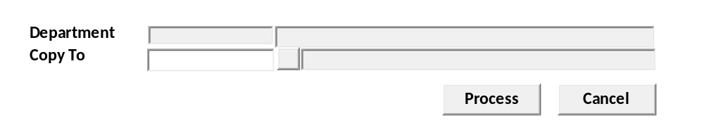
Test
- Load Department
[CR03]
SELECT CDEPT_CODE, CDEPT_NAME FROM GSM_DEPARTMENT (NOLOCK)
WHERE CCOMPANY_ID = 'Login Company Id'
AND CDEPT_CODE = [Selected Dept Code]

EXEC RSP_GS_GET_DEPT_DETAIL 'Login Company Id', 'Selected CDEPT_CODE', 'Login User Id'
[CR03/]

Display Data:
  - "Department"
    - Textbox
    - Display = CDEPT_CODE, CDEPT_NAME
    - VARCHAR(100)

  - "Copy To"
    - Lookup
    - Display = CDEPT_CODE, CDEPT_NAME
    - Value =
[CR03]
SELECT A.CDEPT_CODE, A.CDEPT_NAME FROM GSM_DEPARTMENT A (NOLOCK)
WHERE A.CCOMPANY_ID = 'Login Company Id'
AND NOT EXISTS (SELECT TOP 1 1 FROM GSM_TRANSACTION_APPROVAL B (NOLOCK)
WHERE B.CCOMPANY_ID = 'Login Company Id'
AND B.CDEPT_CODE = 'Selected Dept Code'
)
EXEC RSP_GS_GET_DEPT_LOOKUP_LIST [Login Company Id], [Login User Id], 'GSM05000'
[CR03/]
Copy To Process:
EXEC RSP_COPY_TO_USER_APPR @CCOMPANY_ID, @CTRANSACSTION_CODE, @CDEPT_CODE, @CCOPY_TO_DEPT, @CUSER_LOGIN_ID

COPY FROM PROCESS
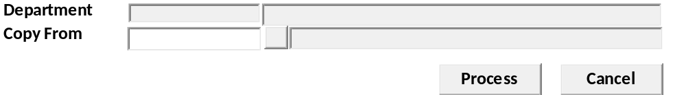
Test
- Load Department
[CR03]
SELECT CDEPT_CODE, CDEPT_NAME FROM GSM_DEPARTMENT (NOLOCK)
WHERE CCOMPANY_ID = 'Login Company Id'
AND CDEPT_CODE = [Selected Dept Code]

EXEC RSP_GS_GET_DEPT_DETAIL 'Login Company Id', 'Selected CDEPT_CODE', 'Login User Id'
[CR03/]

Display Data:
  - "Department"
    - Textbox
    - Display = CDEPT_CODE, CDEPT_NAME
    - VARCHAR(100)

  - "Copy From"
    - Lookup
    - Display = CDEPT_CODE, CDEPT_NAME
    - Value =
[CR03]
SELECT A.CDEPT_CODE, A.CDEPT_NAME FROM GSM_DEPARTMENT A (NOLOCK)
WHERE A.CCOMPANY_ID = 'Login Company Id'
AND NOT EXISTS (SELECT TOP 1 1 FROM GSM_TRANSACTION_APPROVAL B (NOLOCK)
WHERE B.CCOMPANY_ID = 'Login Company Id'
AND B.CDEPT_CODE = 'Selected Dept Code'
)
EXEC RSP_GS_GET_DEPT_LOOKUP_LIST [Login Company Id], [Login User Id], 'GSM05000'
[CR03/]
Copy To Process:
EXEC RSP_COPY_FROM_USER_APPR @CCOMPANY_ID, @CDEPT_CODE, @CCOPY_FROM_DEPT, @CUSER_LOGIN_ID

- Tutup program dan kembali ke Numbering List

CR LIST
CR No. | Description | Notes
CR01  RE, 7 June 2023 | Perbaikan query header tab Approval  Menambahkan kondisi edit process tab Approval
CR02  RE, 11 August 2023 | Mengubah Last Updated → Updated
CR03  RE, 20 Sept 2023 | Mengubah query manual ke SP
CR04  RE, 21 Nov 2023 | Tab Numbering enable jika “Using Incremental Document Number” = True dan Tab Approval enable jika “Using Approval” = True  Mengubah CSEQUENCE ajadi ISEQUENCE (untuk Tab Approval)

